**NVIDIA DGX Spark**

**NVIDIA DGX Spark** is a powerful AI computer designed to help **developers, researchers, and data scientists** work on AI projects. It lets you build, test, and run AI models locally, without needing huge data center resources.

**Key Features:**

* **Superpower for AI:** It has super-fast processing, combining a special CPU (Grace) with a strong GPU (Blackwell), allowing it to handle very complex tasks quickly.
* **Big Memory:** It comes with a lot of memory (128 GB), so it can work on large AI models (like those with up to 200 billion parameters).
* **Easy Connection:** You can connect two DGX Spark systems to work on even bigger models (up to 405 billion parameters).
* **Software for AI:** It comes with tools and software from NVIDIA, like AI libraries and pre-trained models, to make building and running AI projects easier.
* 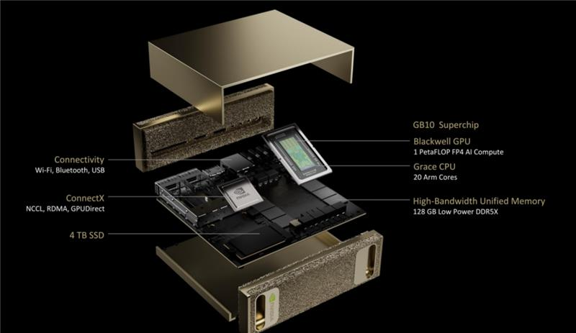

**The NVIDIA DGX Spark can have a significant financial impact on NVIDIA in several ways:**

1. **New Revenue Stream:** By offering a high-performance, AI-focused product like DGX Spark, NVIDIA taps into the growing demand for AI and machine learning solutions. This product is likely targeted at organizations, research labs, and large enterprises, which are willing to pay a premium for cutting-edge AI hardware. This leads to an increase in sales and revenue.
2. **Brand Leadership in AI:** NVIDIA has already established itself as a leader in AI hardware with its GPUs, but the DGX Spark further solidifies its position. As companies and research institutions increasingly adopt AI, NVIDIA benefits from being a go-to provider of the technology needed to run large AI models. This strengthens its brand and attracts long-term partnerships.
3. **Enterprise Market Penetration:** DGX Spark is designed for enterprise-level AI workloads. By targeting high-value sectors such as data science, AI research, edge computing, and AI development, NVIDIA captures a more lucrative market. These customers usually invest in high-end hardware, contributing significantly to NVIDIA's profitability.
4. **Subscription and Software Sales:** In addition to hardware sales, NVIDIA also offers software tools and AI frameworks as part of its overall ecosystem (like the NVIDIA AI software stack). As companies buy DGX Spark machines, they are also likely to invest in these software solutions, which generates recurring revenue.
5. **Higher-Price Products:** DGX Spark comes with high-end components (like GPUs and CPUs), meaning it’s priced at a premium. This premium pricing boosts NVIDIA's average selling price (ASP) for their hardware products. More expensive machines like DGX Spark lead to higher overall revenue per unit sold compared to lower-end products.
6. **Long-Term Growth:** With the rise of AI, companies are likely to need increasingly powerful hardware, and NVIDIA is well-positioned to meet this demand. As AI adoption grows, DGX Spark can become a standard tool for AI-driven industries, helping NVIDIA maintain steady financial growth over the long term.